**MELVILLE SENIOR HIGH SCHOOL**

**Year 11 Mathematics Specialist**

**Test 3 Semester 1, 2021**

**Topic 1.3 Vectors and Circle Geometry**

**Weighting - 7%**





**NAME: _______SOLUTIONS___________________ DATE_______________**

**Time allowed for this calculator-free section**

Calculator-Free /25

Calculator-Assumed

/25

Test Total /50

= %

Reading time before commencing work: one minute

Working time for this section: twenty-five minutes

**Time allowed for this calculator-assumed section**

Reading time before commencing work: one minute

Working time for this section: twenty-six minutes

**Materials required/recommended for Section One**

***To be provided by the supervisor***

The Question/Answer Booklet

Formula Sheet

***To be provided by the candidate***

Standard items: pens, pencils, pencil sharpener, eraser, correction fluid/tape, ruler, highlighters

Special items: nil

**Materials required/recommended for Section Two**

***To be provided by the supervisor***

The Question/Answer booklet

Formula sheet (retained from Section One)

***To be provided by the candidate***

Standard items: pens (blue/black preferred), pencils (including coloured), sharpener,  
correction fluid/tape, eraser, ruler, highlighters

Special items: drawing instruments, templates, notes on one unfolded sheet of A4 paper, and up to three calculators approved for use in this assessment.

**Important note to candidates**

No other items may be used in this assessment. It is **your** responsibility to ensure that you do not have any unauthorised notes or other items of a non-personal nature in the assessment room. If you have any unauthorised material with you, hand it to the supervisor **before** reading any further.

**Structure of this assessment**

|  |  |  |  |  |  |
| --- | --- | --- | --- | --- | --- |
| Section | Number of questions available | Number of questions to be answered | Working time (minutes) | Marks available | Percentage of Assessment |
| Section One:  Calculator-free | 5 | 5 | 25 | 25 | 50% |
| Section Two:  Calculator -assumed | 4 | 4 | 25 | 25 | 50% |
|  | | | **Totals** | **50** | 100% |

**Instructions to candidates**

1. The rules for the conduct of Western Australian examinations/assessment are detailed in the current *Year 11 Information Handbook.* Sitting this assessment implies that you agree to abide by these rules.

2. Write your answers in the spaces provided in this Question/Answer Booklet.

Spare pages are included at the end of this booklet.

They can be used for planning your responses and/or as additional space if required to continue an answer.

* Planning: If you use the spare pages for planning, indicate this clearly at the top of the page.
* Continuing an answer: If you need to use the space to continue an answer, indicate in the original answer space where the answer is continued, i.e. give the page number. Fill in the number of the question(s) that you are continuing to answer at the top of the page.

3. **Show all your working clearly**. Your working should be in sufficient detail to allow your answers to be checked readily and for marks to be awarded for reasoning. Incorrect answers given without supporting reasoning cannot be allocated any marks. For any question or part question worth more than two marks, valid working or justification is required to receive full marks. If you repeat an answer to any question, ensure that you cancel the answer you do not wish to have marked.

4. It is recommended that you **do not use pencil**, except in diagrams.

**Section One: Calculator-free 50% (****25 Marks)**

This section has **five (****5)** questions. Answer **all** questions. Write your answers in the spaces provided.

Working time for this section is 25 minutes.

**Question 1 4 marks**

The diagram below shows an isosceles triangle $BED$, its circumcircle and tangent at one vertex $B$.

∠ABD = $x$ and ∠CBE = $y.$

Prove that 

Image result for red tick pngImage result for red tick pngImage result for red tick pngImage result for red tick png

***Various Answers – mark accordingly***

**Question 2 6 marks**

Determine the value for the variables in each of the following diagram

Image result for red tick pngImage result for red tick png 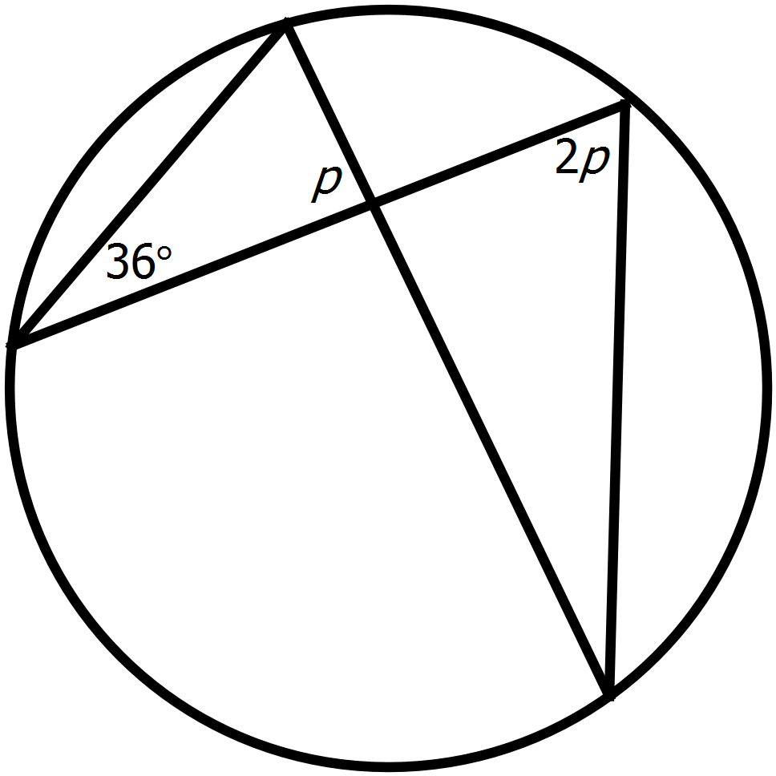

1. Image result for red tick png

Image result for red tick png 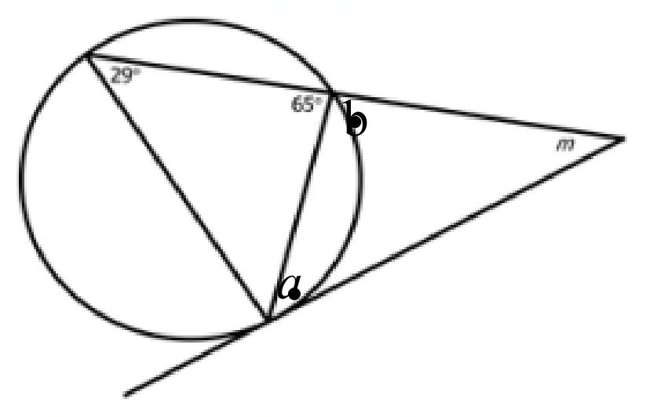

1. Image result for red tick pngImage result for red tick png  
   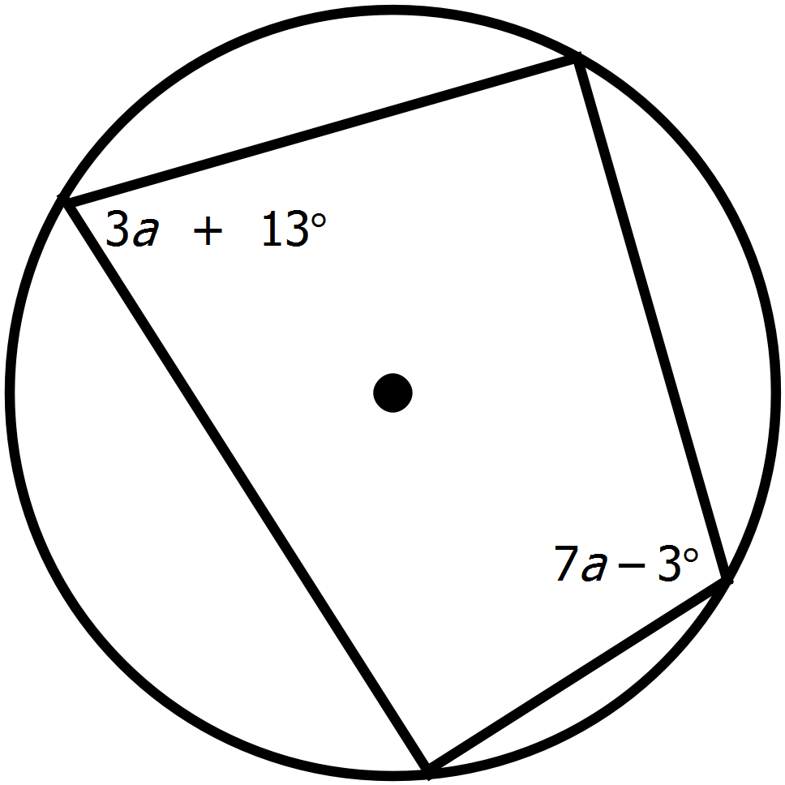

**Question 3 6 marks**

The position vector of points A, B and C with respect to the origin O are $2i-j$, $-3i-3j$ and $-6i$ respectively.

1. Find the position vector of A relative to B. (1 mark)

Image result for red tick png

1. Find the displacement of C relative to B. (1 mark)

Image result for red tick png

1. The position vector of the point D relative to C is $-2i+3j$. find the position vector of D relative to O.

(2 marks)

Image result for red tick pngImage result for red tick png

1. Find the distance between A and D. (2 marks)

Image result for red tick png

Image result for red tick png

**Question 4 3 marks**

AD and AN are tangents to the circle with centre O.   
Prove that Δ ARO and Δ AJO are congruent.

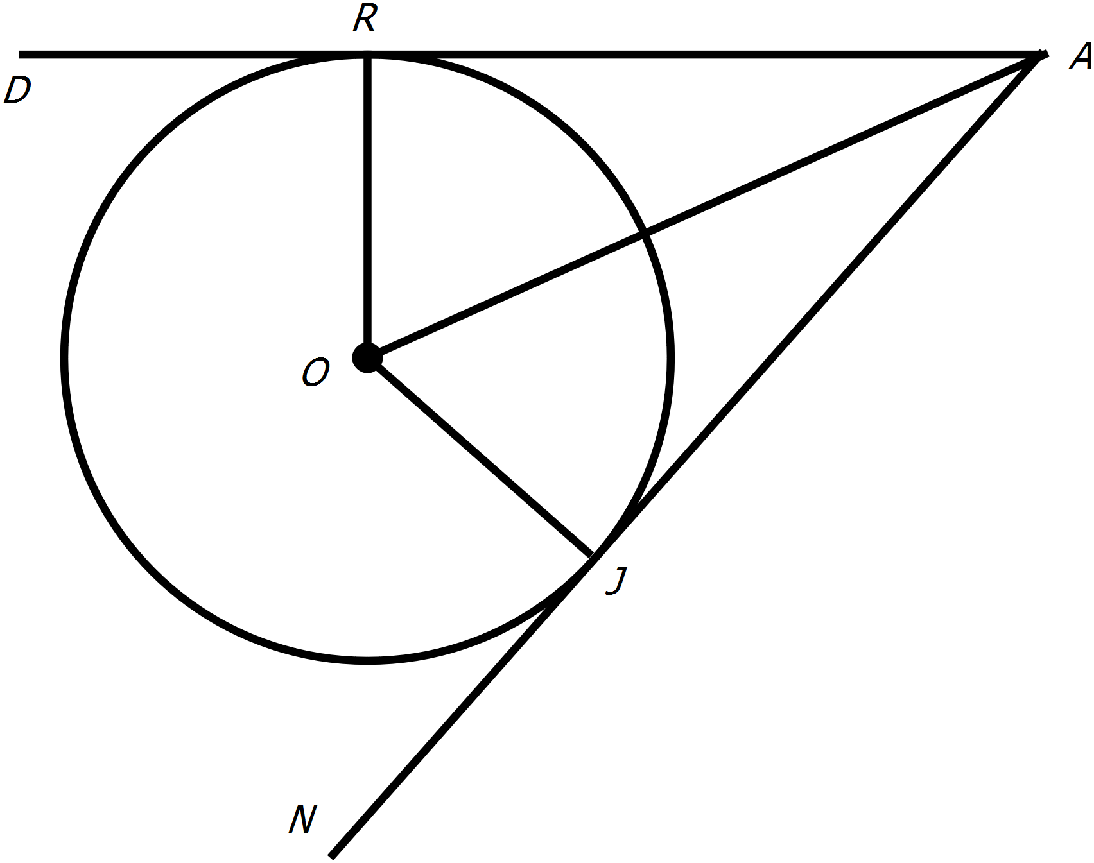

Image result for red tick pngImage result for red tick pngImage result for red tick png

*correct corresponding angles

*correct congruency test

***Various Answers – mark accordingly***

**Question 5 6 marks**

Three vertical forces of $300 N$, $400 N$ and $500 N$ are being exerted on the same side of an object. The $300 N$ and $500 N$ forces are exerted either side of the $400 N$ force at angles of $30°$ and $45°$ respectively.

1. Find the total acting force. (4 marks)

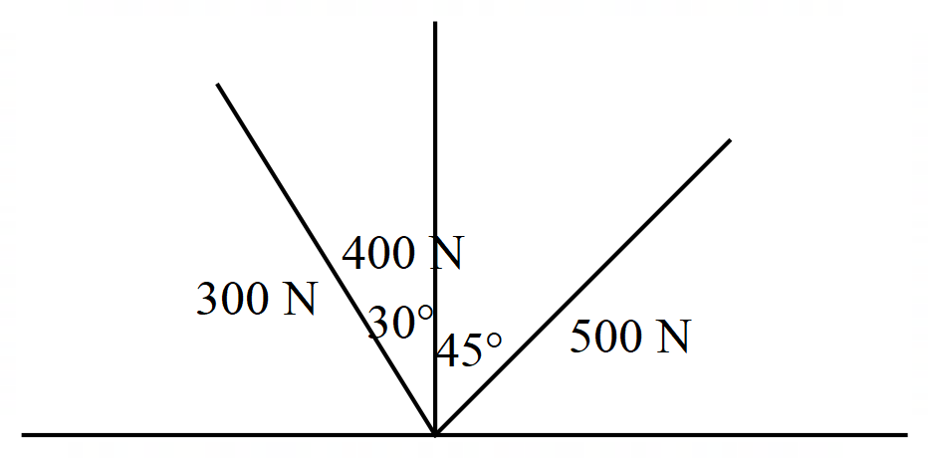

Image result for red tick png

Image result for red tick png

Image result for red tick png

Image result for red tick png

1. Show how to find the bearing of that force. (2 marks)

Image result for red tick png

Image result for red tick png

***Various Answers – mark accordingly***

**End of Section One**

**Additional working space**

Question _________